1. **Use Case:**
   1. Use Case Description

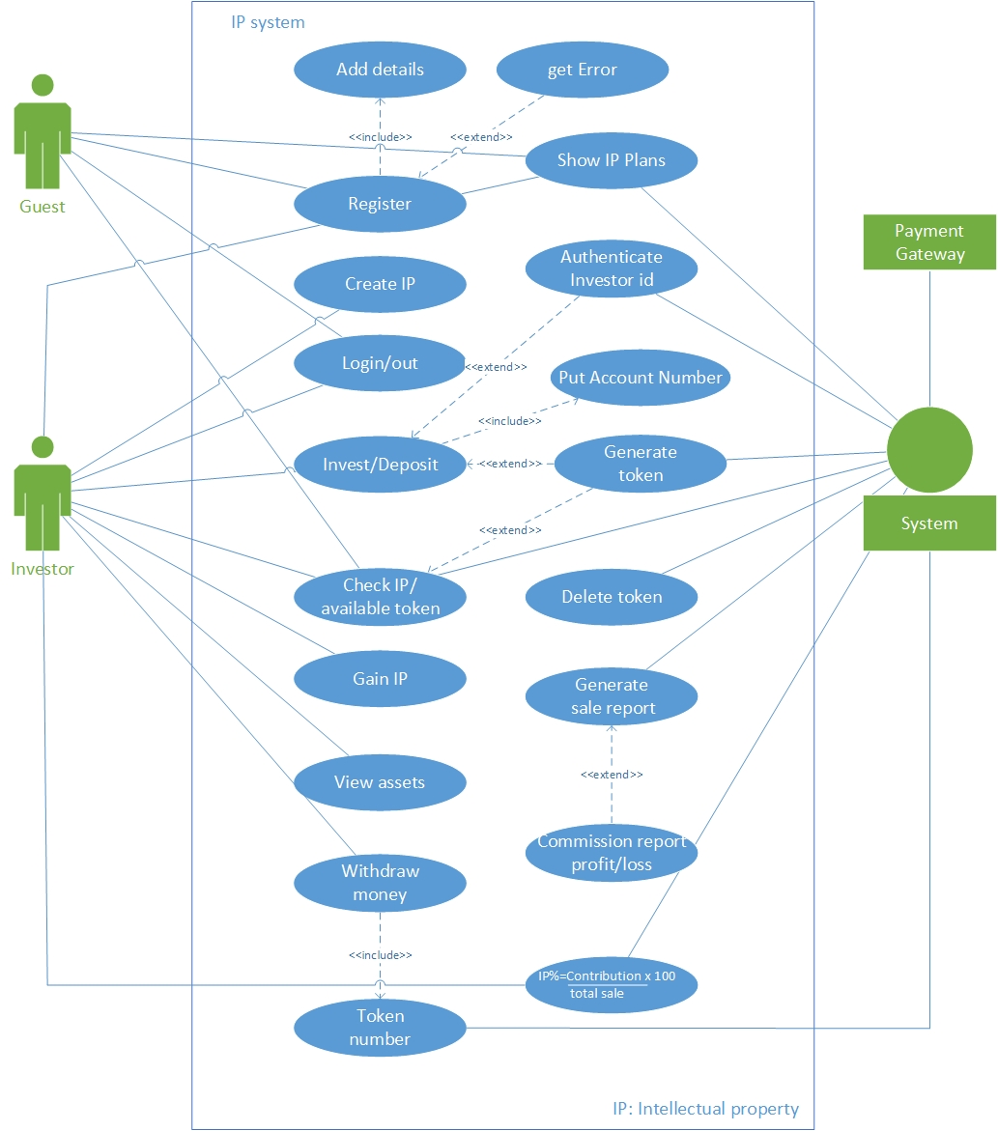

* 1. Use Case Description

|  |  |  |  |
| --- | --- | --- | --- |
| **<Use case 1: Registration>** | | | |
| **Actors:**  Primary Actor: User  Secondary Actor: System | | | |
| **Feature:** User will enter the credentials to get himself registered. | | | |
| **Use case Id:** | | 1 | |
| **Pre-condition:** | | User must have the correct information | |
| **Scenarios** | | | |
|  | **Action** | | **Software Reaction** |
| **1** | User will click the registration button | | System will take the user to registration page. |
| **2** | User will enter personal details | | System will take the user input and make sign up button green. |
| **3** | User will click the sign-up button | | System will check the details and allow account creation |
| **Alternate Scenarios:** | | | |
| **1:** Information is not correct. | | | |
| **Post Conditions** | | | |
| **1** | As the use case is completed successfully, User successfully registered. | | |

|  |  |  |  |
| --- | --- | --- | --- |
| **<Use case 2: Login>** | | | |
| **Actors:**  Primary Actor: User  Secondary Actor: System | | | |
| **Feature** User will enter the credentials to login. | | | |
| **Use case Id:** | | 2 | |
| **Pre-condition:** | | User name  Password | |
| **Scenarios** | | | |
|  | **Action** | | **Software Reaction** |
| **1.** | User will choose login from the given options | | System will take the user to login page |
| **2.** | User will put the login details and submit | | System verifies the details and passes the user to the main screen. |
| **Alternate Scenarios:** | | | |
| Username/password is not correct, Try again. | | | |
| **Post Conditions** | | | |
|  | **Description** | | |
| **1** | As the use case is completed successfully the user can check and subscribe to IP plans. | | |

|  |  |  |  |
| --- | --- | --- | --- |
| **<Use case 3: Create IP>** | | | |
| **Actors:**  Primary Actor: User  Secondary Actor: System | | | |
| **Feature:** User will be able to create IP. | | | |
| **Use case Id:** | | 3 | |
| **Pre-condition:** | | User must be registered. | |
| **Scenarios** | | | |
|  | **Action** | | **Software Reaction** |
| **1** | User will check available tokens | | System will enlist all available tokens |
| **2** | User will create IP based on his idea | | System will authenticate user and subsequently add him to investor list |
| **3** | User will invest in available IPs | | System will authenticate user making him an investor and assigning IP rights |
| **Alternate Scenarios:** | | | |
| **1:** Information is not correct. | | | |
| **Post Conditions** | | | |
| **1** | As the use case is completed successfully, system return result. | | |

|  |  |  |  |
| --- | --- | --- | --- |
| **<Use case 4: Invest/Deposit >** | | | |
| **Actors:**  Primary Actor: User  Secondary Actor: System | | | |
| **Feature** User will be able to invest in order to get benefits. | | | |
| **Use case Id:** | | 4 | |
| **Pre-condition:** | | User must have enough amount to subscribe to the desired plan. | |
| **Scenarios** | | | |
|  | **Action** | | **Software Reaction** |
| **1.** | User selects the investment option on main page. | | System will return a page with multiple fields asking for user credentials |
| **2.** | User will enter the details and deposit the money using an account number | | Payment gateway will generate a unique id against the user and send it to the main system, and the system will store that unique id to keep the information secure. |
| **Alternate Scenarios:** | | | |
| **Post Conditions** | | | |
|  | **Description** | | |
| **1** | As the use case is completed successfully, the system will display the result. | | |

|  |  |  |  |
| --- | --- | --- | --- |
| **<Use case 5: Generate sales report >** | | | |
| **Actors:**  Primary Actor: System  Secondary Actor: User | | | |
| **Feature** System will generate reports based on software sales. | | | |
| **Use case Id:** | | 5 | |
| **Pre-condition:** | | There must be software sales. | |
| **Scenarios** | | | |
|  | **Action** | | **Reaction** |
| **1.** | System will generate profit/loss report for individual users | | Users will view generated reports to have an idea about individual profit/loss |
| **2.** | System will also generate a comprehensive report on sale of software mentioning each user’s contribution | | User (Investor) will see the detailed reports and devise future strategy for investment |
| **3.** | System will highlight the IP rights with most profit/loss | | Users will have the option to revisit their investment approach |
| **Alternate Scenarios:** | | | |
| **Post Conditions** | | | |
|  | **Description** | | |
| **1** | As the use case is completed successfully, the system will display the result. | | |

|  |  |  |  |
| --- | --- | --- | --- |
| **<Use case 6: Show IP Status >** | | | |
| **Actors:**  Primary Actor: User  Secondary Actor: System | | | |
| **Feature** User will be able to check current IP status | | | |
| **Use case Id:** | | 6 | |
| **Pre-condition:** | | User must be an investor. | |
| **Scenarios** | | | |
|  | **Action** | | **Software Reaction** |
| **1.** | User will request the current IP status | | System will enlist all the details about software sales, profit/loss |
| **2.** | User will subscribe to notifications related to software sales, reports generation, profit/loss | | System will notify user as soon as an one of the subscribed event happens. |
| **Post Conditions** | | | |
|  | **Description** | | |
| **1** | As the use case is completed successfully, the system will display the result. | | |

|  |  |  |  |
| --- | --- | --- | --- |
| **<Use case 7: Withdraw money >** | | | |
| **Actors:**  Primary Actor: User  Secondary Actor: System | | | |
| **Feature** User will be able to withdraw money | | | |
| **Use case Id:** | | 7 | |
| **Scenarios** | | | |
|  | **Action** | | **Software Reaction** |
| **1.** | User will request if a withdrawal is possible | | System will take user to the withdrawal page showing withdrawal details |
| **2.** | User will apply for withdrawal after entering amount | | System will check whether the asked amount is available for withdrawal |
| **3.** | User will complete the request of withdrawal by click confirm | | System will facilitate the withdrawal through payment gateway. |

1. **Sequence Diagram:**

